Website Research
As part of AS1.3 you must complete research and analysis of existing websites, evaluating each website to establish your design ideas.
Complete 5 Website Research examples from http://www.designfridge.co.uk/

At the bottom of this research task you have to complete a Final Evaluation on how you can use certain aspects of your Website Research to establish your design ideas.

Website Print Screen
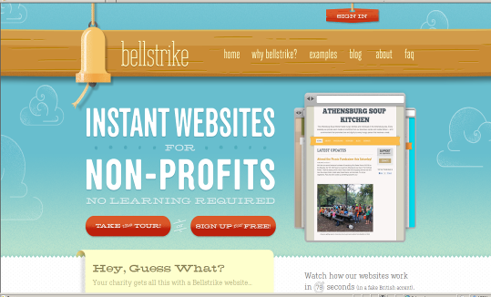
I like this feature because the rollover effect of the menu buttons
This could be better if they would put a rollover image as well to achieve harmony because their other navigational buttons have rollovers
http://bellstrike.com/

DESIGN LAYOUT PRINCIPLES

Sequence – the website has sequence using its sidebars. Its menu buttons reminisce its content. The banner is a let down though because the light blue colour is not suitable in my opinion

Harmony – the menu colour harmonise with the content colour of the website

NAVIGATION – navigation is user-friendly because they made the website comfortable to navigate by utilising menus and the footer

IMAGERY – imagery used is very consistent throughout different webpage especially the background images.

ANIMATIONS – N/A

CONTENT – content is very brief and understandable. It is relevant on the topics that they wanted to convey to the viewer

COLOUR – the harmony of the colours red blue and brown are implemented throughout the website

FONTS - this font in the examples page is very not harmonised because it doesn’t look modern compared to the template they have used

LINKS – page sequence is achieved successfully because there is a hierarchy of information present
This could be better if they would utilise the sidebar and used it as a bay of navigational links
Website Print Screen
I like this feature because of the layering effect applied by making the moon image as a forground to the website while the text serves as a middleground and the blue black gradient colour is the background
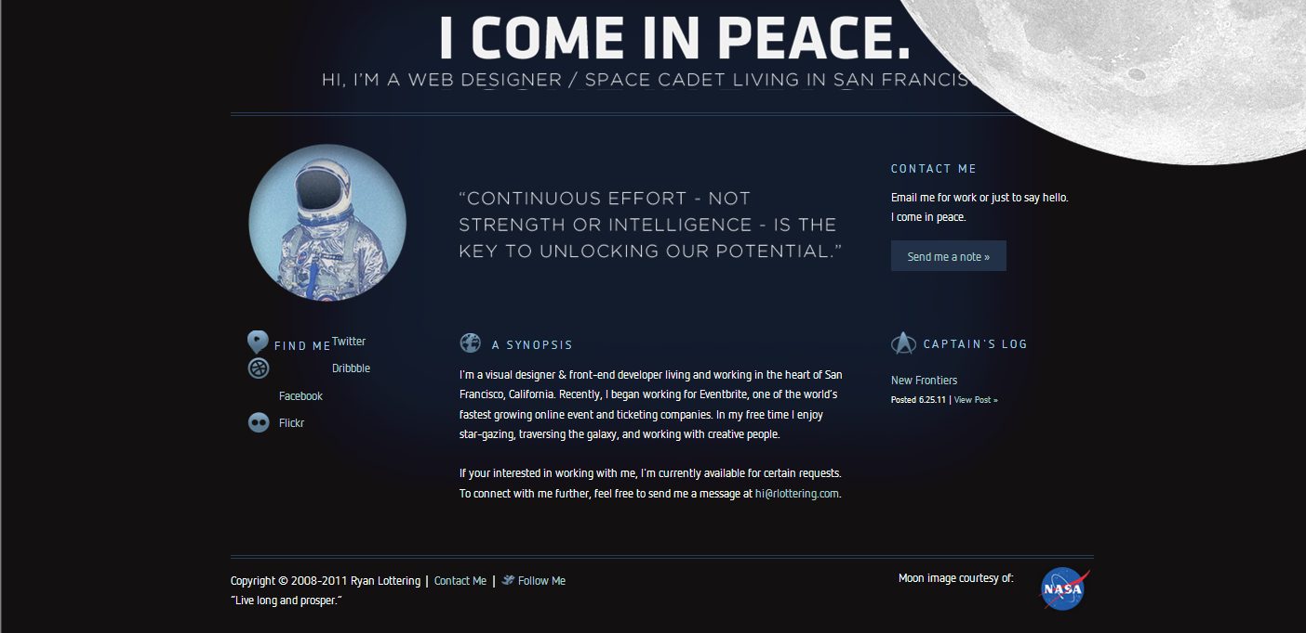
http://www.rlottering.com/

DESIGN LAYOUT PRINCIPLES

Harmony - The use of the black space in the website is a very good representation of the theme of their website

Proximity – alignment is a key feature in this website because they utilise and limit paragraphs to fit their screen

NAVIGATION – navigation is quite mediocre because the ‘about’ page also served as the home page

IMAGERY – the image of an astronaut and the use of the moon as a foreground is a perfect representation of a space fanatic. Images are kept to a minimal though

ANIMATIONS – N/A

CONTENT – content is brief and w/o much detail at all. Content was blog-like

COLOUR – the use of a dark blue colour is very effective in conveying the theme of the website designer – space fan, web developer

FONTS – the use of a non-serif font for headings and serif fonts for paragraphs are kept to a minimal number of 4

LINKS – as a visual freelancer he managed to link his present and previous works into his new website

Website Print Screen
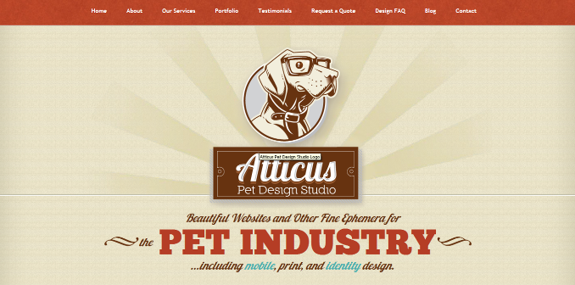
I like this feature because the image of a dog instantly introduces to a viewer what the website is about. The animation behind it would give more emphasis on the image
http://www.atticuspetdesign.com/

DESIGN LAYOUT PRINCIPLES

Harmony and Balance – the use of red, light brown and white for this website complements the dark brown colour in the title image of the website. The briefness of the information on the homepage is excellent in webdesign

Proportion – the picture of a dog in its homepage gives the viewer the instant idea that this website is about pet’s webpages

NAVIGATION – navigation is the A+ for this website because they are the only one who managed to utilise the ‘back to top’ button on their website

IMAGERY – the image of a dog as a pet on the home page is very essential in introducing the website to the viewer

ANIMATIONS – the looping flash animation on this website gives the website a thumbs-up because they have implemented the animation effectively to improve emphasis on the ‘dog’ image

CONTENT – the content on its other pages are not really brief with no pictures which makes the website very boring. Content management was a let down

COLOUR – The red-ish and brown colour used in the website follows harmony

FONTS – The fonts was a let down because more than 3 fonts are used in this website

LINKS – too many links are used on this website

Website Print Screen
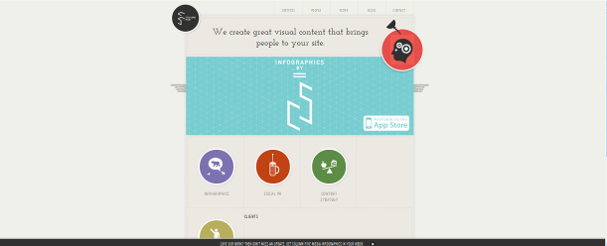
I like this features because the flash-feature highlights the main points of this website
This sub-menu button could be improved by placing them here

http://columnfivemedia.com/

DESIGN LAYOUT PRINCIPLES

Alignment and proximity – The flash-feature animation in this website is used very well in the terms of bringing the viewer the main points in the website

Contrast and Harmony – the use of the grey colour utilises the use of the font colour in the menu of the website while the white space renders a contrasting colour for the website

NAVIGATION – website was easy to navigate all the way through

ANIMATIONS – the flash-feature on the home page highlights the main points of this website

CONTENT – the content on its other pages are brief and informative

COLOUR – the colours used were very consistent throughout the website

FONTS – The fonts used are in harmony and proportion with the logo and images

LINKS – the links are working properly and are organised in a user-friendly manner

Website Print Screen
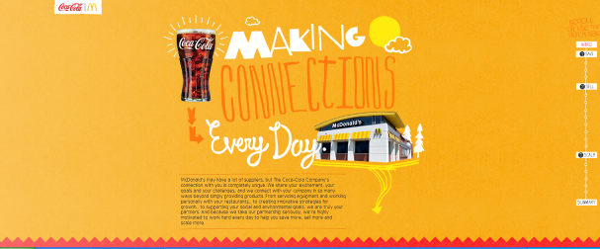
I like this features because the colour and content was organised in an effort-less like manner
The website could be improved by adding more pages to it
http://makingconnectionseveryday.com/#intro

DESIGN LAYOUT PRINCIPLES

Contrast - The graphics in this website is very superb in a way of the details they have used. The colour blue space contrast the colour red coke colour

Alignment and proximity – the text in this website is centred to implement its connection to the image and the image colours complements the text colours

I might have to reconsider using the fonts in this website

NAVIGATION – navigation was made easier by using flash features on the right side

ANIMATIONS – N/A

CONTENT – content is arranged in by using sub-section of ONE page instead of using two or more pages

COLOUR – the colours complement the pictures very well in terms of harmony

FONTS – there were excellent font used in this website but the problem is that they were more than 3

LINKS – the flash-based links are working properly

Final Evaluation; I could use one or two of the fonts featured in these websites and also some the flash animation and function that the last website uses. In observation to these websites, it has come to my knowledge that most of their headings are aligned at the centre while the paragraphs are aligned left. Sequence, easy navigation and proportion are the main things found at a successful website.

